Annex: Country Report

Country Report should be discussed among and authorized by the concerned officials in your organization (and with former participants if possible) prior to the submission, in order for the participant to prepare a feasible action plan as an output of the training program based on these documents. Even if there are two participants from the same country, it is strongly requested that each participant should submit Country Report from different perspectives of education in the country. (Handwriting is not recommended.)

Please write the Country Report with the following contents (about 5 pages, not more than 10 pages). In addition to the paper, you are asked to prepare for a 15 minutes presentation with focusing on section 5 and 6 at the training program.
1. Name
2. Position/ Organization
3. Duties you are in charge at your organization (in detail)

4. Socio-economic situation in your country
Describe concisely the socio-economic situation using an appropriate set of indicators.
(Expand this section as necessary)

5. Concise description of the country’s education sector and key issues of education quality
Include (a) statement of issues and their background, and (b) corresponding policies and their means of implementation, of the issues, focusing on inclusive and equitable learning and its outcomes.
Answer concisely the following questions:
      - First, explain the key education issues, their background, and corresponding policies
      - A. Who took the leading role in formulating the policy? (i.e. country ownership vs. influence of donor)
B. Were key stakeholders involved in the process through, for instance, consultations between the central and local education systems? Who were they? How?
C. Were the stakeholders informed of the policy reform before/during the implementation?
      - How were lessons from experiences used to achieve inclusive and equitable learning and its outcomes?
      - How evidence from research results were used?
(Expand this section as necessary)

6. A summary table of education policy matrix *
(a) Make a reference to the existing matrix or, in its absence, create a fresh one describing: i) overall policy goals, ii) indicators to assess achievement of the policy goals, iii) key policy actions that are planned for achieving the policy goals, iv) expected outcomes of the policy actions, and v) indicators to assess achievement of the expected outcomes. If the country uses results-based financing indicators, such as by the GPE new funding model or the World Bank disbursement-linked indicators, please use them. You are asked to reproduce a summary matrix for a major education sector program (or project). Explain the process of identifying the outcome indicators (or indicators for releasing funds), and discuss in what way it is useful to achieve the project/program objectives. This section should focus on issues of inclusive and equitable learning and its outcomes.

(b) Pick up one policy outcomes in the area of inclusive learning outcomes and draw a result chain**.
(Please bring a copy of existing education policy documents that contain the matrix.)
________________________
* A policy matrix is a document that is used to summarize an agreement between the government and aid agencies for the education sector program. It stipulates policy goals, policy measures and policy actions as conditions. Satisfying the conditions will trigger disbursement of donor funds. Examples of an extract of the policy matrix and the disbursement linked indicators are shown at the end of this Annex.
** A result chain describes how intended results (policy objectives) will be achieved by showing the causal relationship between inputs/activities, outputs, and outcomes. Similarly, a “theory of change” is used in the policy formulation/evaluation,
(Expand this section as necessary, or use a separate sheet.)

7. Process of evidence-based education policy formulation in your country
Explain (a) how (in what ways and to what extent) stakeholders and policy makers are (not) involved in the process of policy making and designing policy measures for achieving policy objectives, and (b) what conscious efforts are being made (if not, why) to incorporate knowledge from the successful education practice, lessons from international cooperation and findings from research.
(Expand this section as necessary)

A Sample Policy Matrix (extract):
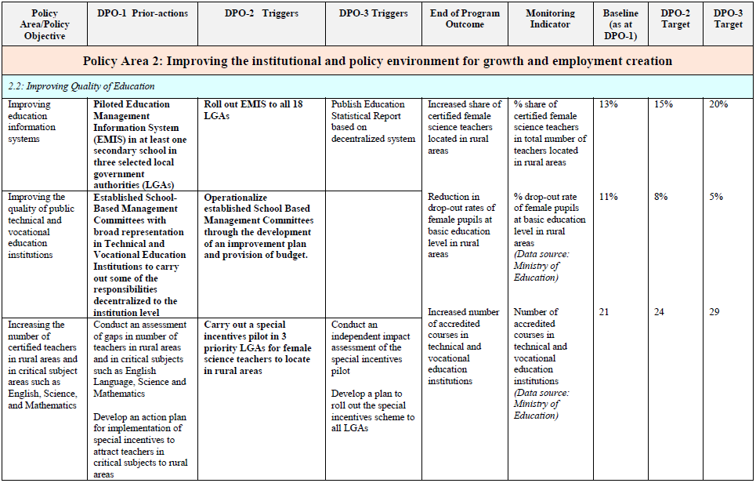
Source: World Bank (Nigeria: First Edo State Growth and Employment Support Credit)

Sample of Results Chain (Indonesia):
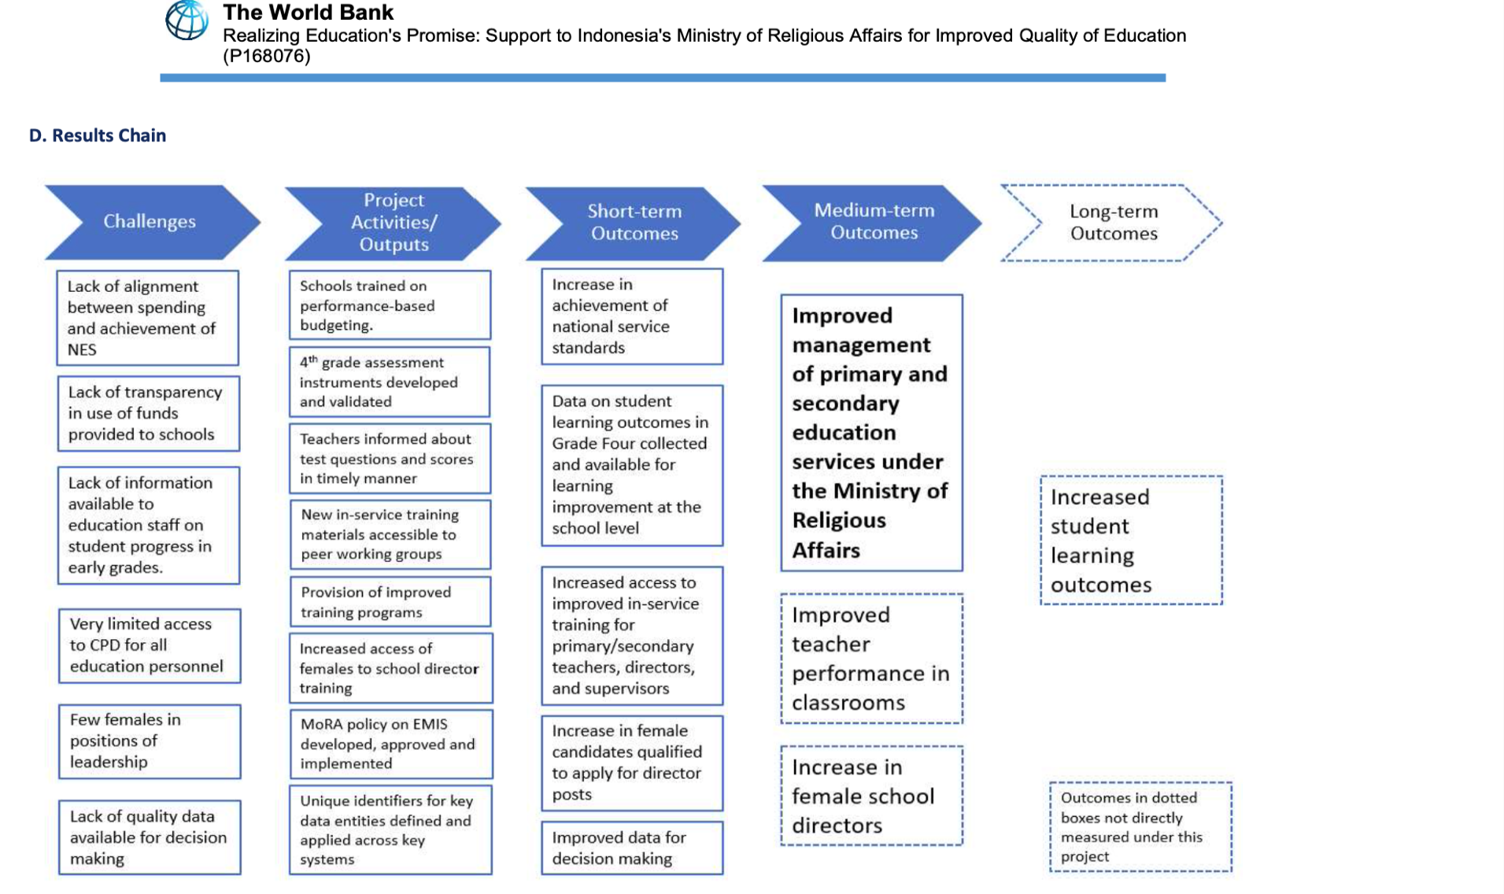
Source: World Bank (Indonesia: Realizing Education’s Promise)
Sample of Theory of Change (Malawi)
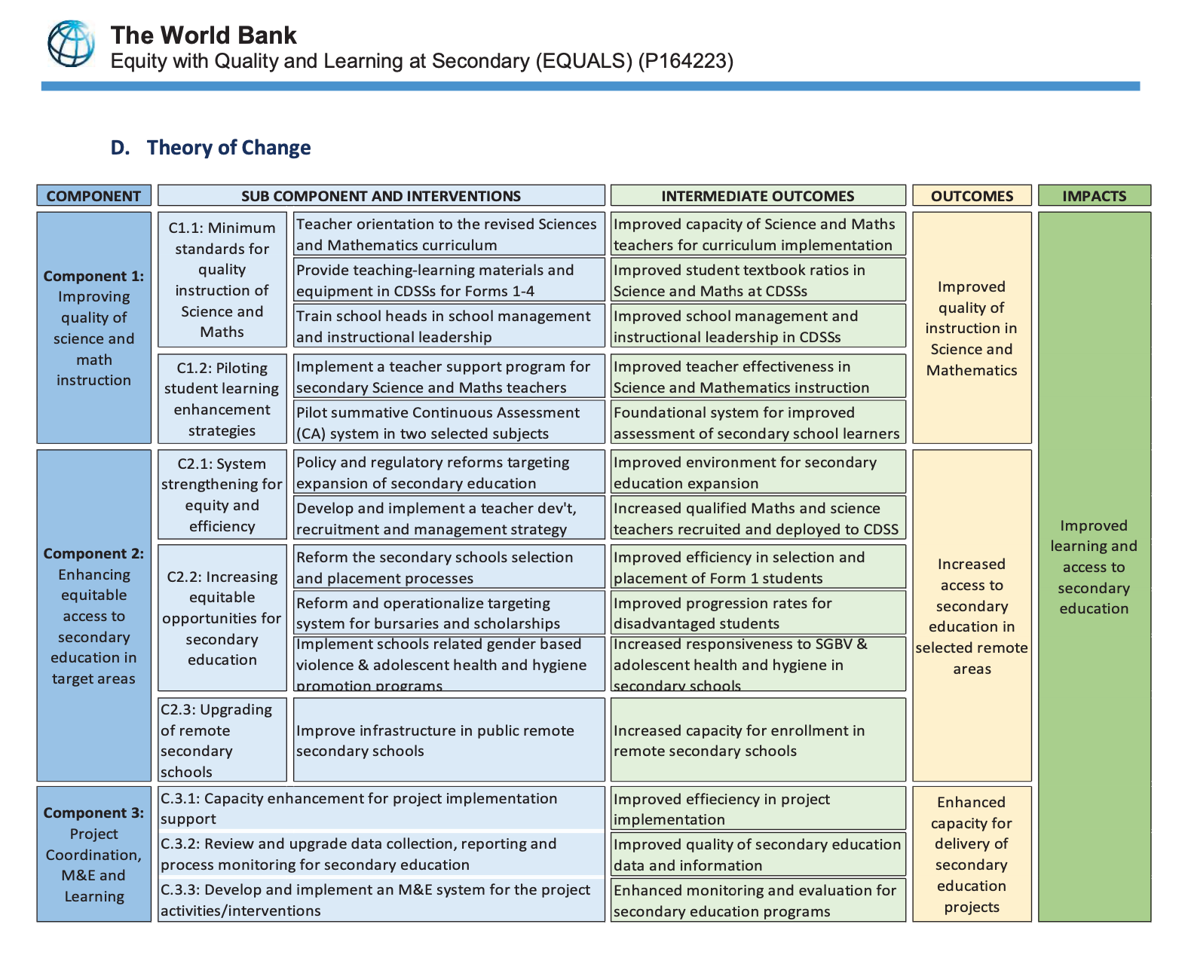
Source: World Bank (Malawi Equity with Quality and Learning at Secondary)

